Stewardship Process 2025-26

Dear Parishioner,

Welcome to the stewardship process for the fiscal year July 2025 – June 2026. We have amazing opportunities ahead of us and, with God’s grace, and your cooperation with that grace, we will see just what our Heavenly Father has in store for us! There are a few pieces to this process:

* A printout of the information we have in our system.
* A blank *Household Information* form to use if you need.
  + On the back of that page, you will find the *Time – Talent – Treasure* form.
* An *Additional Questionnaire* that will help in our planning and vision.

**To participate completely online please go to:** <sta-stb.org/stewardship/>

The information you verify or add to our parish database will be crucial in communicating with you and your family all the important news that an active parishioner will utilize to deepen their relationship with Christ and His Bride the Church. Your discernment of the time, talents, and treasure that you are called to place before our Lord at Saints Aloysius & Benedict will help us accurately budget for the coming fiscal year. You will also be given the opportunity to sign up for our brand-new online giving initiative! Your commitment of time and talent will also enable leaders to call upon a great array of volunteers to complete crucial ministry at your parish, and in the larger community.

On the additional questionnaire you will find a section titled **First Fruits Evangelization**. This is a way to describe how we will go out into all the world making disciples of every nation – we will start with those in your own home, or right down the street. These ‘first fruits’ are those who the Lord has placed close to you, those you are most likely to call to a new way of life as you live out your faith. I ask that you be specific with who it is the Lord is calling you to evangelize – once that person is identified, start right away praying that Jesus may enlighten their heart and mind.

You may desire to speak with your pastor about this evangelization effort, about what the Lord is asking of you in terms of time, talent, and treasure, your involvement in the parish, or any number of issues and situations. You are always welcome to make an appointment, or get in touch with me:

|  |  |  |
| --- | --- | --- |
| **pastor@stafalcons.com** | **502-314-1771 (Cell)** | **fradam.youcanbook.me** |

**Returning your stewardship information and additional questionnaire** – as much as we are able, we try to provide online access to the resources of the parish. As we together grow in our capacity to close that loop, we want to make sure you have every opportunity to contribute to this process. You therefore have three options for completing these forms: (1) fill out everything online, (2) drop your paperwork into the collection basket at church, or (3) mail your information back in. We are also planning opportunities to have staff available after several Masses throughout the season of Lent. Whichever way you choose to complete these forms; I highly encourage you to do so. You will hear about the benefits of stewardship throughout Lent. We are hoping to bring the Stewardship Process to a close by Easter Sunday – April 20.

We at Saints Aloysius and Benedict are two parishes, with one heart,loving and serving Central Bullitt County and we welcome your contribution to these efforts. Remember, we are building up the local Catholic Community for you, your neighbor, and your children for generations to come.

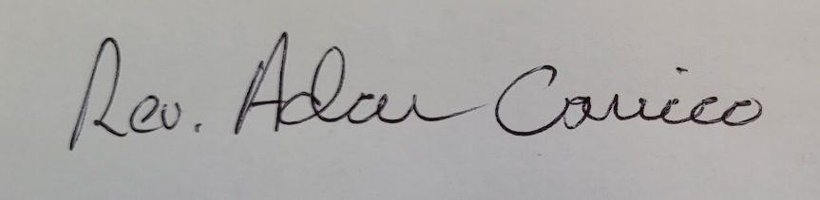Two Parishes, One Heart,

Rev. Adam Carrico ~ Pastor

